UNALEX
MULTILIGUAL INFORMATION FOR THE UNIFORM INTERPRETATION OF THE INSTRUMENTS OF JUDICIAL COOPERATION IN CIVIL MATTERS
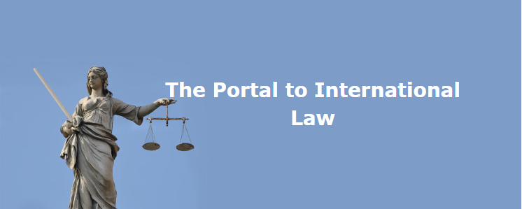

The Project unalex, co-funded by the European Union and coordinated by Professor Andreas Schwartze, University of Innsbruck, provides information for the uniform interpretation of the instruments of judicial cooperation in civil matters. In particular, the aims of the project are:
- expansion of the unalex international case collection to coverage of all European legal instruments of judicial cooperation in civil matters;
- extension of language versions of case headnotes (en, de, fr, it, es);
- updating of Compendia, translation of Compendia titles, drafting of new Compendia;
- dissemination and awareness raising will bring the availability of the unalex case collection to the attention of judges, lawyers, and notaries in all Member States.
This will provide the grounds on which legal literature evaluating the European practice of the legal instruments can be based; the project will promote the development of such literature through the setting up of a Network of Authors. In order to facilitate its creation, topic related conferences will be organised.

PROJECT DURATION
2015 – 2017

PROJECT PARTNERS
University of Innsbruck (Coordinator)
IPR Verlag, Germany (Co-Beneficiary)
Università degli Studi di Genova – DDG, Italy (Co-Beneficiary)
Právnická fakulta Univerzity Karlovy v Praze, Czech Republic (Associate Partner)
SIA “Rígas Juridiská augstskola”, Latvia (Associate Partner)
Universitat de València. Estudi General – Departamento de Derecho Internacional, Spain (Associate Partner)
University of Zagreb – Faculty of Law, Croatia (Associate Partner)

DISPO PARTICIPANTS
Ilaria QUEIROLO, Laura CARPANETO

OTHER PARTICIPANTS
Marion Hodac, France
Apostolos Anthimos, Greece and Cyprus
Egle Zemlyte, Lithuania
Professor Mateusz Pilich, Poland
Professor Anabela Susana de Sousa Gonçalves, Portugal
Ioana Burduf, Romania
Erik Sinander, Sweden
Professor Ales Galic, Slovenia
Ana Maria Ruiz Martin, Spain
Professor Tuulikki Mikkola, Finland
Professor Ian Refalo and John Refalo, Malta
Professor Kasper Steensgaard, Denmark
Veerle van den Eeckhout, Belgium/ Netherlands
Professeur Gilles Cuniberti, Luxemburg
Professor Gabor Palasti, Hungary

KEY WORDS
European Union Law, judicial cooperation in civil matters.

FUNDINGS
European Commission, JUST/2014/JCOO/AG/CIVI/7736

